**NANDHA ENGINEERING COLLEGE**

(An Autonomous Institution, Affiliated to Anna University, Chennai)

# ERODE–638052



**DEPARTMENT OF ARTIFICIAL INTELLIGENCE AND DATA SCIENCE**

**(TABLEAU -TWO CREDIT COURSE)**

**PROJECT TITLE : IBM- HR ANALYTICS USING TABLEAU**

## Analysis Report

## Submitted by

## K. Elango (23AI016)

## (II-YEAR / B.TECH-AI&DS)

## IV - SEMESTER

**TABLEAU**

Tableau is a leading data visualization and business intelligence platform that transforms complex HR data into clear, actionable insights. Renowned for its user-friendly interface, Tableau enables HR professionals, even those without technical expertise, to create interactive dashboards, dynamic charts, and comprehensive reports. By connecting seamlessly to HR systems like Workday, SAP SuccessFactors, or Excel, Tableau facilitates real-time analysis of workforce metrics such as employee performance, turnover rates, and diversity trends. Its drag-and-drop functionality and robust visualization capabilities empower HR teams to identify patterns, monitor key performance indicators (KPIs), and make data-driven decisions to enhance employee engagement and organizational success. With Tableau, HR departments can present compelling, visually appealing insights to stakeholders, fostering strategic workforce planning and improved outcomes.

**IBM-HR ANALYTICS**

HR Analytics is the systematic process of collecting, analyzing, and interpreting data related to human resources to improve decision-making, optimize workforce performance, and align HR strategies with organizational goals. It involves using data-driven insights to understand employee behaviors, predict trends, and address challenges such as attrition, recruitment, engagement, and productivity.

**Key Aspects of HR Analytics :**

* Data Collection:

Gathering data on employee demographics, performance metrics, compensation, satisfaction levels, tenure, and more (e.g., from datasets like WA_Fn-UseC_-HR-Employee-Attrition.csv).

* Analysis:

Applying statistical methods, predictive modeling, and visualization tools (e.g., Tableau) to identify patterns, correlations, and trends.

**CHART 1 : MONTHLY INCOME DISTRIBUTION BY JOB ROLE**

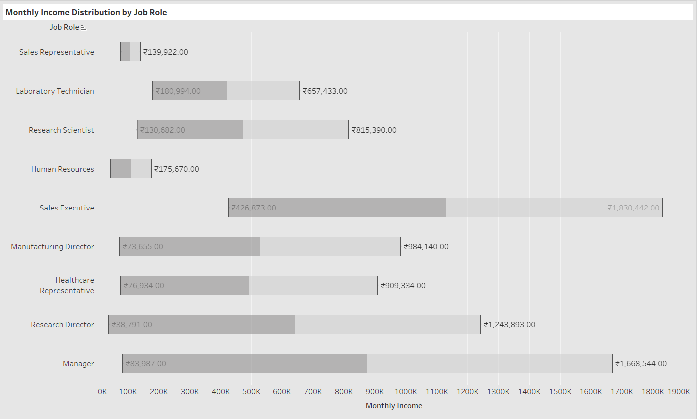

The analysis is about **Monthly Income Distribution by Job Role**:

* It shows the income range (minimum to maximum) for different job roles.
* Roles analyzed include Sales Representative, Laboratory Technician, Research Scientist, Human Resources, Sales Executive, Manufacturing Director, Healthcare Representative, Research Director, and Manager.
* "Sales Executive" and "Manager" have the highest maximum incomes (₹1,830,442 and ₹1,668,544), indicating top-paying positions.
* Roles like "Research Director" and "Healthcare Representative" also show high income ranges.
* Some roles like "Manufacturing Director" and "Research Director" show wide variation between minimum and maximum salaries, suggesting income differences based on experience or performance.

The chart used is a **Horizontal Bar Chart**:

* Each bar shows the income spread for a job role.
* Actual income values are marked at the start and end of each bar for easy comparison.

**CHART2 : ATTRITION BY DEPARTMENT**

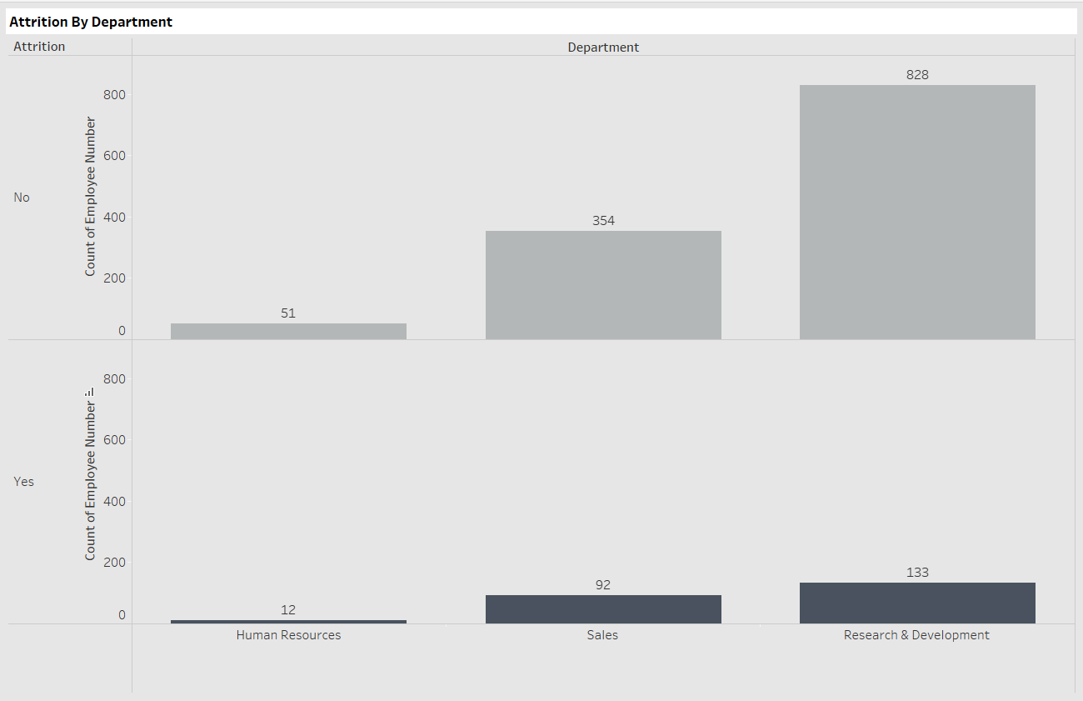

The chart represents **Employee Attrition by Department**, showing the number of employees who stayed ("No") and who left ("Yes") across three departments:

**Human Resources**, **Sales**, and **Research & Development**.

* **Research & Development** has the highest number of employees (828 stayed, 133 left), indicating a large workforce but also notable attrition.
* **Sales** shows 354 employees stayed and 92 left, reflecting significant employee turnover relative to its size.
* **Human Resources** has the smallest workforce (51 stayed, 12 left), with comparatively lower attrition numbers.

The visual uses a **segmented bar chart** to clearly display the employee distribution and highlight which departments experience higher attrition rates.  
It emphasizes that while Research & Development retains the most employees overall, it also faces the highest absolute number of exits.

**CHART 3 : JOB SATISFACTION RATING**

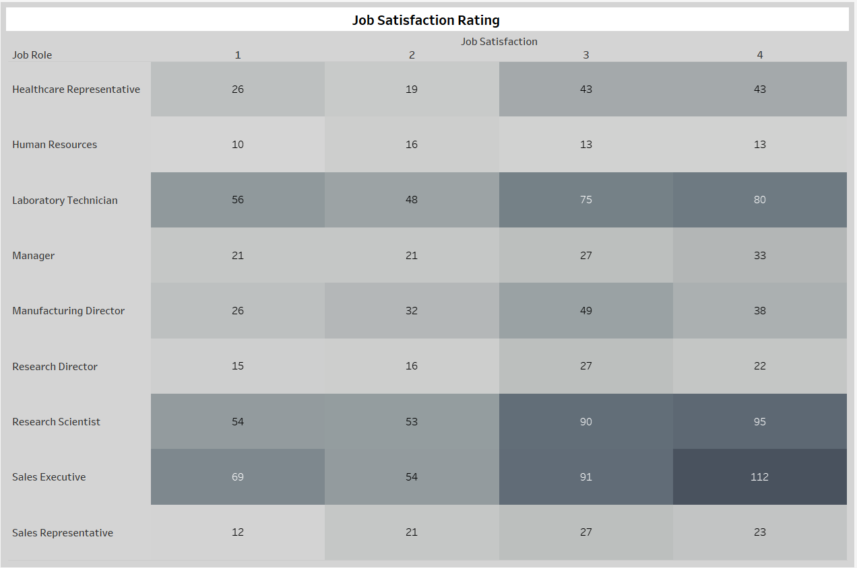

The chart illustrates the **Job Satisfaction Ratings** across different **Job Roles** within an organization, categorized from **1 (Low Satisfaction)** to **4 (High Satisfaction)**.

* **Sales Executives** show the highest number of employees (112) rating their job satisfaction at level 4, suggesting a large proportion are highly satisfied.
* **Research Scientists** also report high satisfaction, with 90 employees at rating 3 and 95 at rating 4, indicating strong engagement in research roles.
* **Laboratory Technicians** have a more even spread but still a notable number (80) reporting the highest satisfaction level.
* In contrast, roles like **Human Resources** and **Research Directors** have relatively fewer employees in higher satisfaction categories, with more even distribution across all ratings.
* **Sales Representatives** show a relatively balanced distribution, but with lower overall numbers, suggesting a smaller team size.

Overall, the chart highlights that **technical and sales-related roles** (Research Scientist, Sales Executive, Laboratory Technician) tend to experience higher job satisfaction compared to administrative or leadership roles (Human Resources, Manager, Research Director).

**CHART 4 : PERFORMANCE RATING VS. PERCENT SALARY HIKE BY ATTRITION**

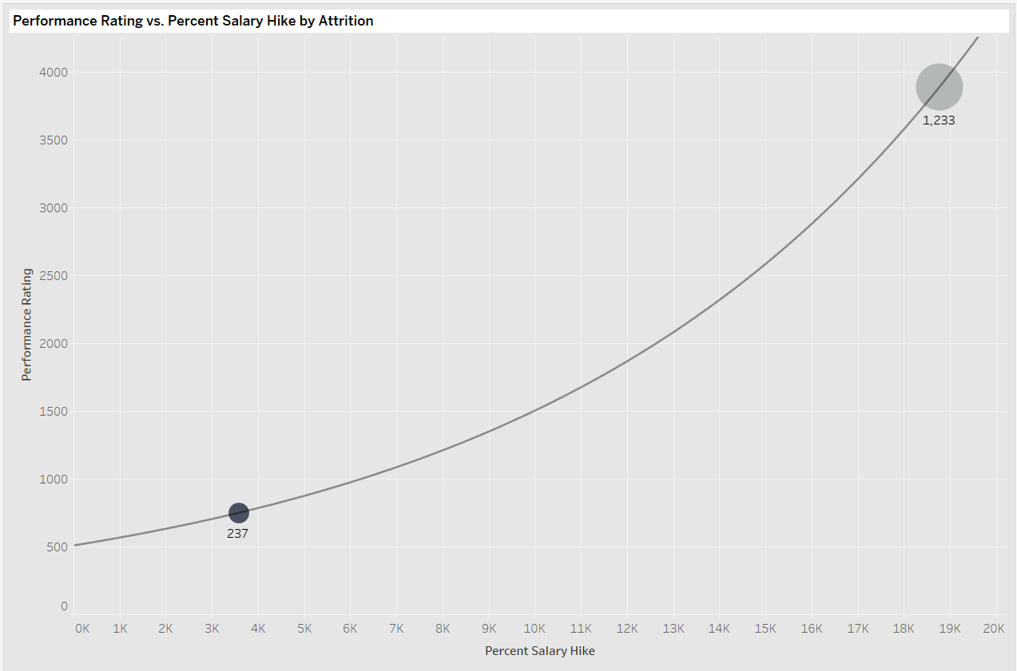

The graph shows **Performance Rating** plotted against **Percent Salary Hike**, separated by **Attrition** status (likely "Yes" and "No").

* Two major groups are visible: one smaller group (237 individuals) with a **lower salary hike (~4K%)** and a corresponding **lower performance rating (~750)**, and another larger group (1,233 individuals) with a **higher salary hike (~18K%)** and a **higher performance rating (~4000)**.
* The size of the bubbles indicates the **number of employees** in each group.
* The curve suggests a **non-linear (exponential) relationship** — as salary hikes increase, performance ratings rise steeply.
* The larger bubble on the right (higher salary hikes) implies that **employees who stayed (less attrition)** received higher salary hikes and showed stronger performance.
* Inshort:  
   Higher salary hikes are **strongly associated** with higher performance ratings and likely lower attrition.  
  Lower salary hikes correlate with **lower performance** and possibly higher attrition.

**CHART 5 : ATTRITION RELATED TO JOB TRAVEL REQUIREMENTS**

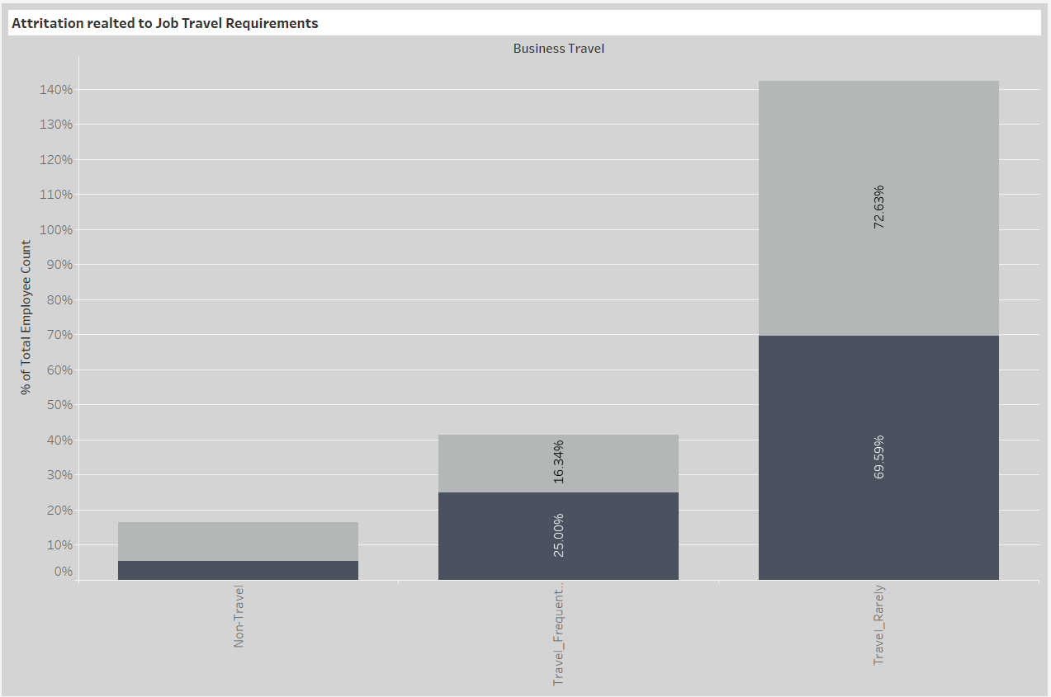

The bar chart shows **Attrition related to Business Travel Requirements**:

* Employees are categorized into **Non-Travel**, **Travel_Frequent**, and **Travel_Rarely** groups.
* **Travel_Rarely** employees form the **largest group** (69.59% + 72.63% = ~142% stacked, indicating many people overall with and without attrition), and also have a **higher proportion of attrition** compared to others.
* **Travel_Frequent** employees have **lower total numbers** but a **higher percentage (25%) of attrition** relative to their group size.
* **Non-Travel** employees have the **lowest attrition rate** (around 5%) and are a very small segment overall (~15% total).
* **Employees who travel rarely** have the **highest count**, but **frequent travelers** show a **higher attrition rate proportionally**.
* **Non-travelers** are the least likely to leave but also represent a **small part of the workforce**.

**CHART 6 : OVERTIME VS. ATTRITION**

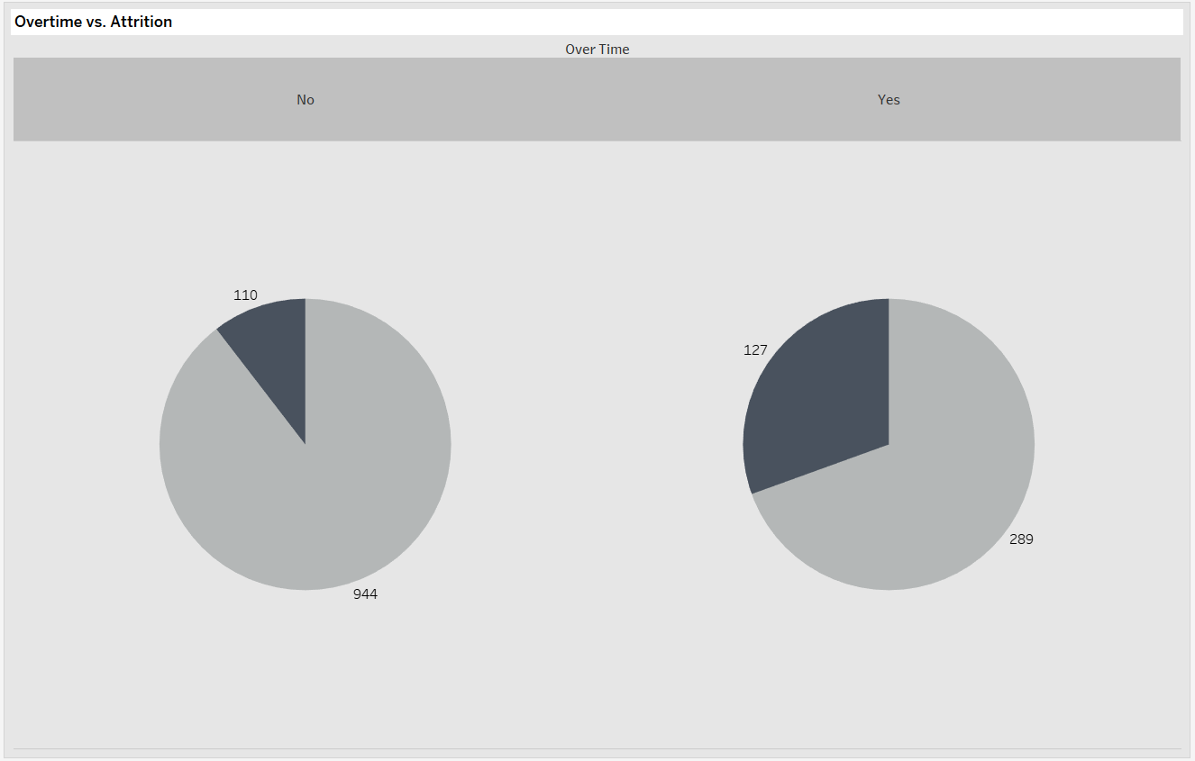

The pie charts show **Overtime vs. Attrition**:

* Left pie: Employees **NOT working overtime** → 110 left (dark area), 944 stayed (light area).
* Right pie: Employees **working overtime** → 127 left (dark area), 289 stayed (light area).

**Insights:**

* Among those **without overtime**, only about **10%** (110 out of 1054) left.
* Among those **with overtime**, a much **higher attrition rate (~30%)** is seen (127 out of 416).

**Summary:**  
🔹 **Employees working overtime are three times more likely to leave** compared to those who don’t work overtime.

**CHART 7 : AGE DISTRIBUTION BY ATTRITION**

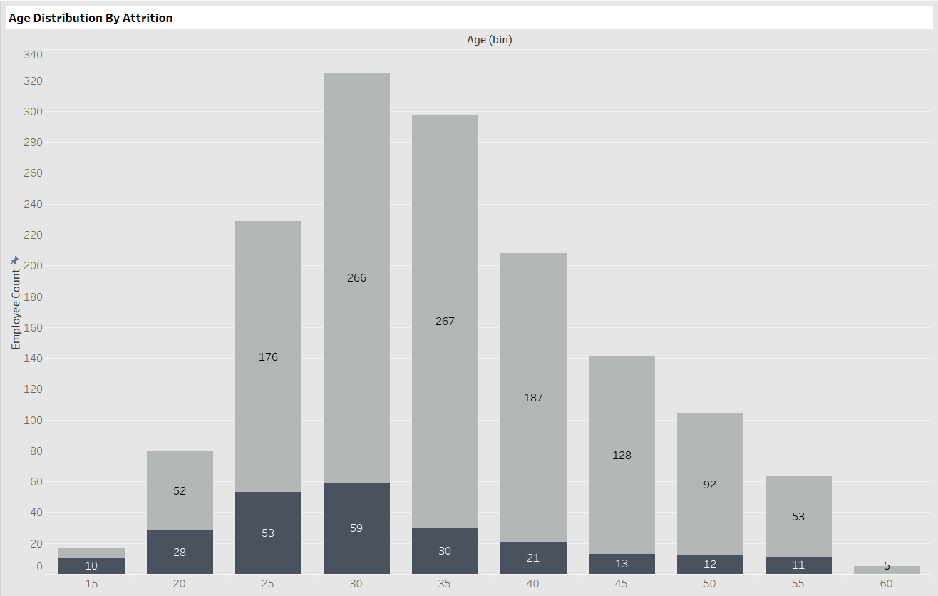

The bar chart shows Age Distribution by Attrition:

* Each bar is split:
  + Dark color → Employees who left (attrition).
  + Light color → Employees who stayed.

Insights:

* Highest attrition is seen between ages 25-35.
* Specifically:
  + Age 25-30: 53 left, 176 stayed.
  + Age 30-35: 59 left, 266 stayed.
  + Age 35-40: Attrition starts reducing (30 left).
* Very low attrition after age 40.

Summary:  
Younger employees (25-35 years) have the highest attrition rate, while employees older than 40 are more stable**.**

**FINAL DASHBOARD**

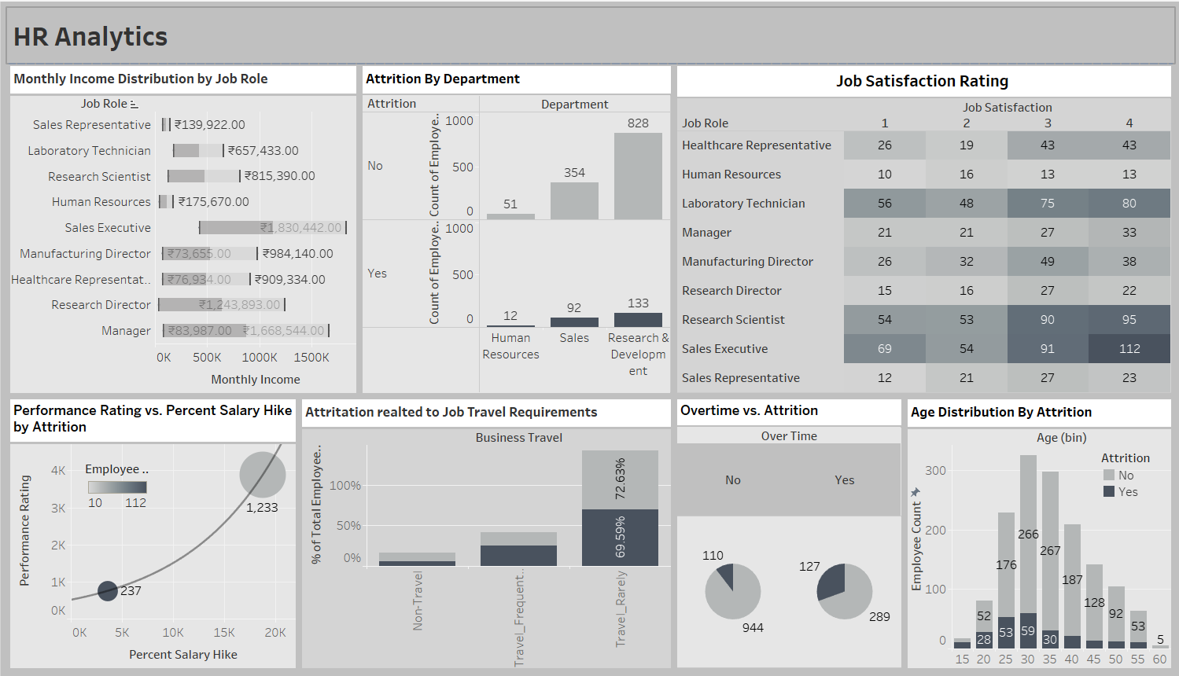

1. Monthly Income Distribution by Job Role

* Shows monthly income range for each job role.
* Example:
  + Research Director has one of the highest salaries (~ ₹1,243,893 to ₹1,830,442).
  + Sales Representative has the lowest (~ ₹139,922).

2. Attrition by Department

* Bar chart displaying how many employees stayed or left across departments.
* Key points:
  + Research & Development had the highest number of both stayers (828) and leavers (133).
  + Sales had 92 employees leave.
  + Human Resources had the least attrition (only 12 left).

3. Job Satisfaction Rating

* Heatmap table linking job roles to satisfaction levels (rated 1 to 4).
* Darker color = More employees at that satisfaction level.
* Example:
  + Research Scientists have many employees highly satisfied (Level 4 = 95 employees).

4. Performance Rating vs. Percent Salary Hike by Attrition

* Bubble chart connecting salary hike % to performance ratings.
* Larger bubbles = More employees.
* Insights:
  + High salary hikes (~20%) correspond with very high performance and lowest attrition.

5. Attrition Related to Job Travel Requirements

* Bar graph showing attrition linked to business travel.
* Findings:
  + Travel_Rarely employees have the highest attrition (~70%+).
  + Non-Travel employees have lower attrition rates.

6. Overtime vs. Attrition

* Pie charts showing how overtime affects attrition.
* Employees who work overtime have much higher attrition (127 left compared to 110 who left without overtime).

7. Age Distribution by Attrition

* Stacked bar chart showing age-wise distribution.
* Observations:
  + Employees aged 25-35 have the highest attrition.
  + Attrition decreases sharply after age 40.

**CONCLUSION**

The HR Analytics dashboard highlights that **employee attrition is primarily driven by younger employees (aged 25–35)**, **those working overtime**, and **employees who travel rarely for business**.  
Departments like **Sales** and **Research & Development** are facing the highest attritionrates.

Lower monthly incomes, moderate job satisfaction levels, and limited salary hikes are key contributors to employees leaving.  
In contrast, employees receiving **higher salary hikes** and those with **higher performance ratings** show significantly **better retention**.  
Improving job satisfaction, offering better work-life balance (especially reducing overtime), and providing competitive salary increments could effectively reduce attrition.